Winterbourne Earls CE Primary School
Summerlug
Winterbourne Earls
Salisbury
SP4 6HA

Tel: 01980 611356
Email: admin@winterbourneearls.wilts.sch.uk
Web: www.winterbourneearls.org
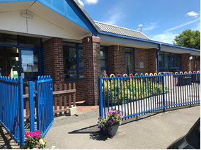

HEADTEACHER: Mrs Philippa Carter
DEPUTY HEADTEACHER: Mr Tom Ackland

School Prospectus 2026-2027
WINTERBOURNE EARLS CHURCH OF ENGLAND PRIMARY SCHOOL

A WELCOME FROM THE HEADTEACHER
Dear Parents and Carers

On behalf of the children, staff, governors and parents, I am delighted to welcome you to our school. Our aim at Winterbourne Earls is to make your child feel happy and secure, believing that within this environment, where good mental health and wellbeing is at the core, all have the chance to flourish. We recognise each child as an individual and, through a focus on warm relationships and good pastoral support, we aim to provide an approach to learning where all are inspired to reach their potential.

We are seeking to further embrace our school vision by developing the partnership we have with all stakeholders in order to become a great school, thriving in every area and at the centre of our village community.

We are seeking to ‘grow’ all leadership roles, with the children taking more of a part in their school journey. Our Christian foundation underpins all we do. Our values of Courage, Honesty, Respect, Inspiration, Stretching our Learning and Thankfulness spell out CHRIST, the heart of our community.

Our school is a welcoming place where we all have high expectations, work hard and love learning. We hope that you will visit our school to see how our learning environment and extensive grounds could be the ideal place for your child to thrive. We look forward to seeing you in the future.

Mrs Philippa Carter

MISSION STATEMENT
At Winterbourne Earls CE Primary School, we aim to encourage a culture of excellence, the highest quality teaching and learning and memorable inclusive experiences. Pupils are inspired to reach their full potential in an environment where relationships reflect the love of Christ.

AIMS OF THE SCHOOL
We believe that all children deserve the very best and we have a commitment to children being happy, healthy, safe, confident individuals, active and responsible citizens and successful leaners. We aim to do this by:
- Creating a positive, affirming, supportive community in which all people are valued and seen as equal as in the eyes of God
- Encouraging an appetite for learning and positive attitudes throughout the whole school community
- Helping children to recognise, understand, handle and appropriately express their emotions in an atmosphere where they feel confident and secure
- Developing necessary skills to enable children to think constructively, work and are inspired to discover more
- Encouraging respect of others’ values, cultures, decisions, lifestyles and individuality
- Developing tolerance in all situations
- Allowing learners to take risks, make mistakes and to experience a fresh start
- Offering a rich and stimulating environment and providing quality education through a broad curriculum which includes extra-curricular activities
- Developing a sense of awe and wonder through this richness of learning
- Establishing effective partnerships; fostering relationships and community links based on the values of mutual respect, generosity, forgiveness and fairness
- Valuing happiness and fostering an environment where there is excitement, enjoyment and sense of purpose for the future
- Having the highest expectations of all individuals and recognising and appreciating their achievements and aspirations
- Developing personal moral values and citizenship

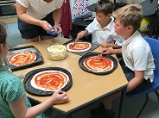
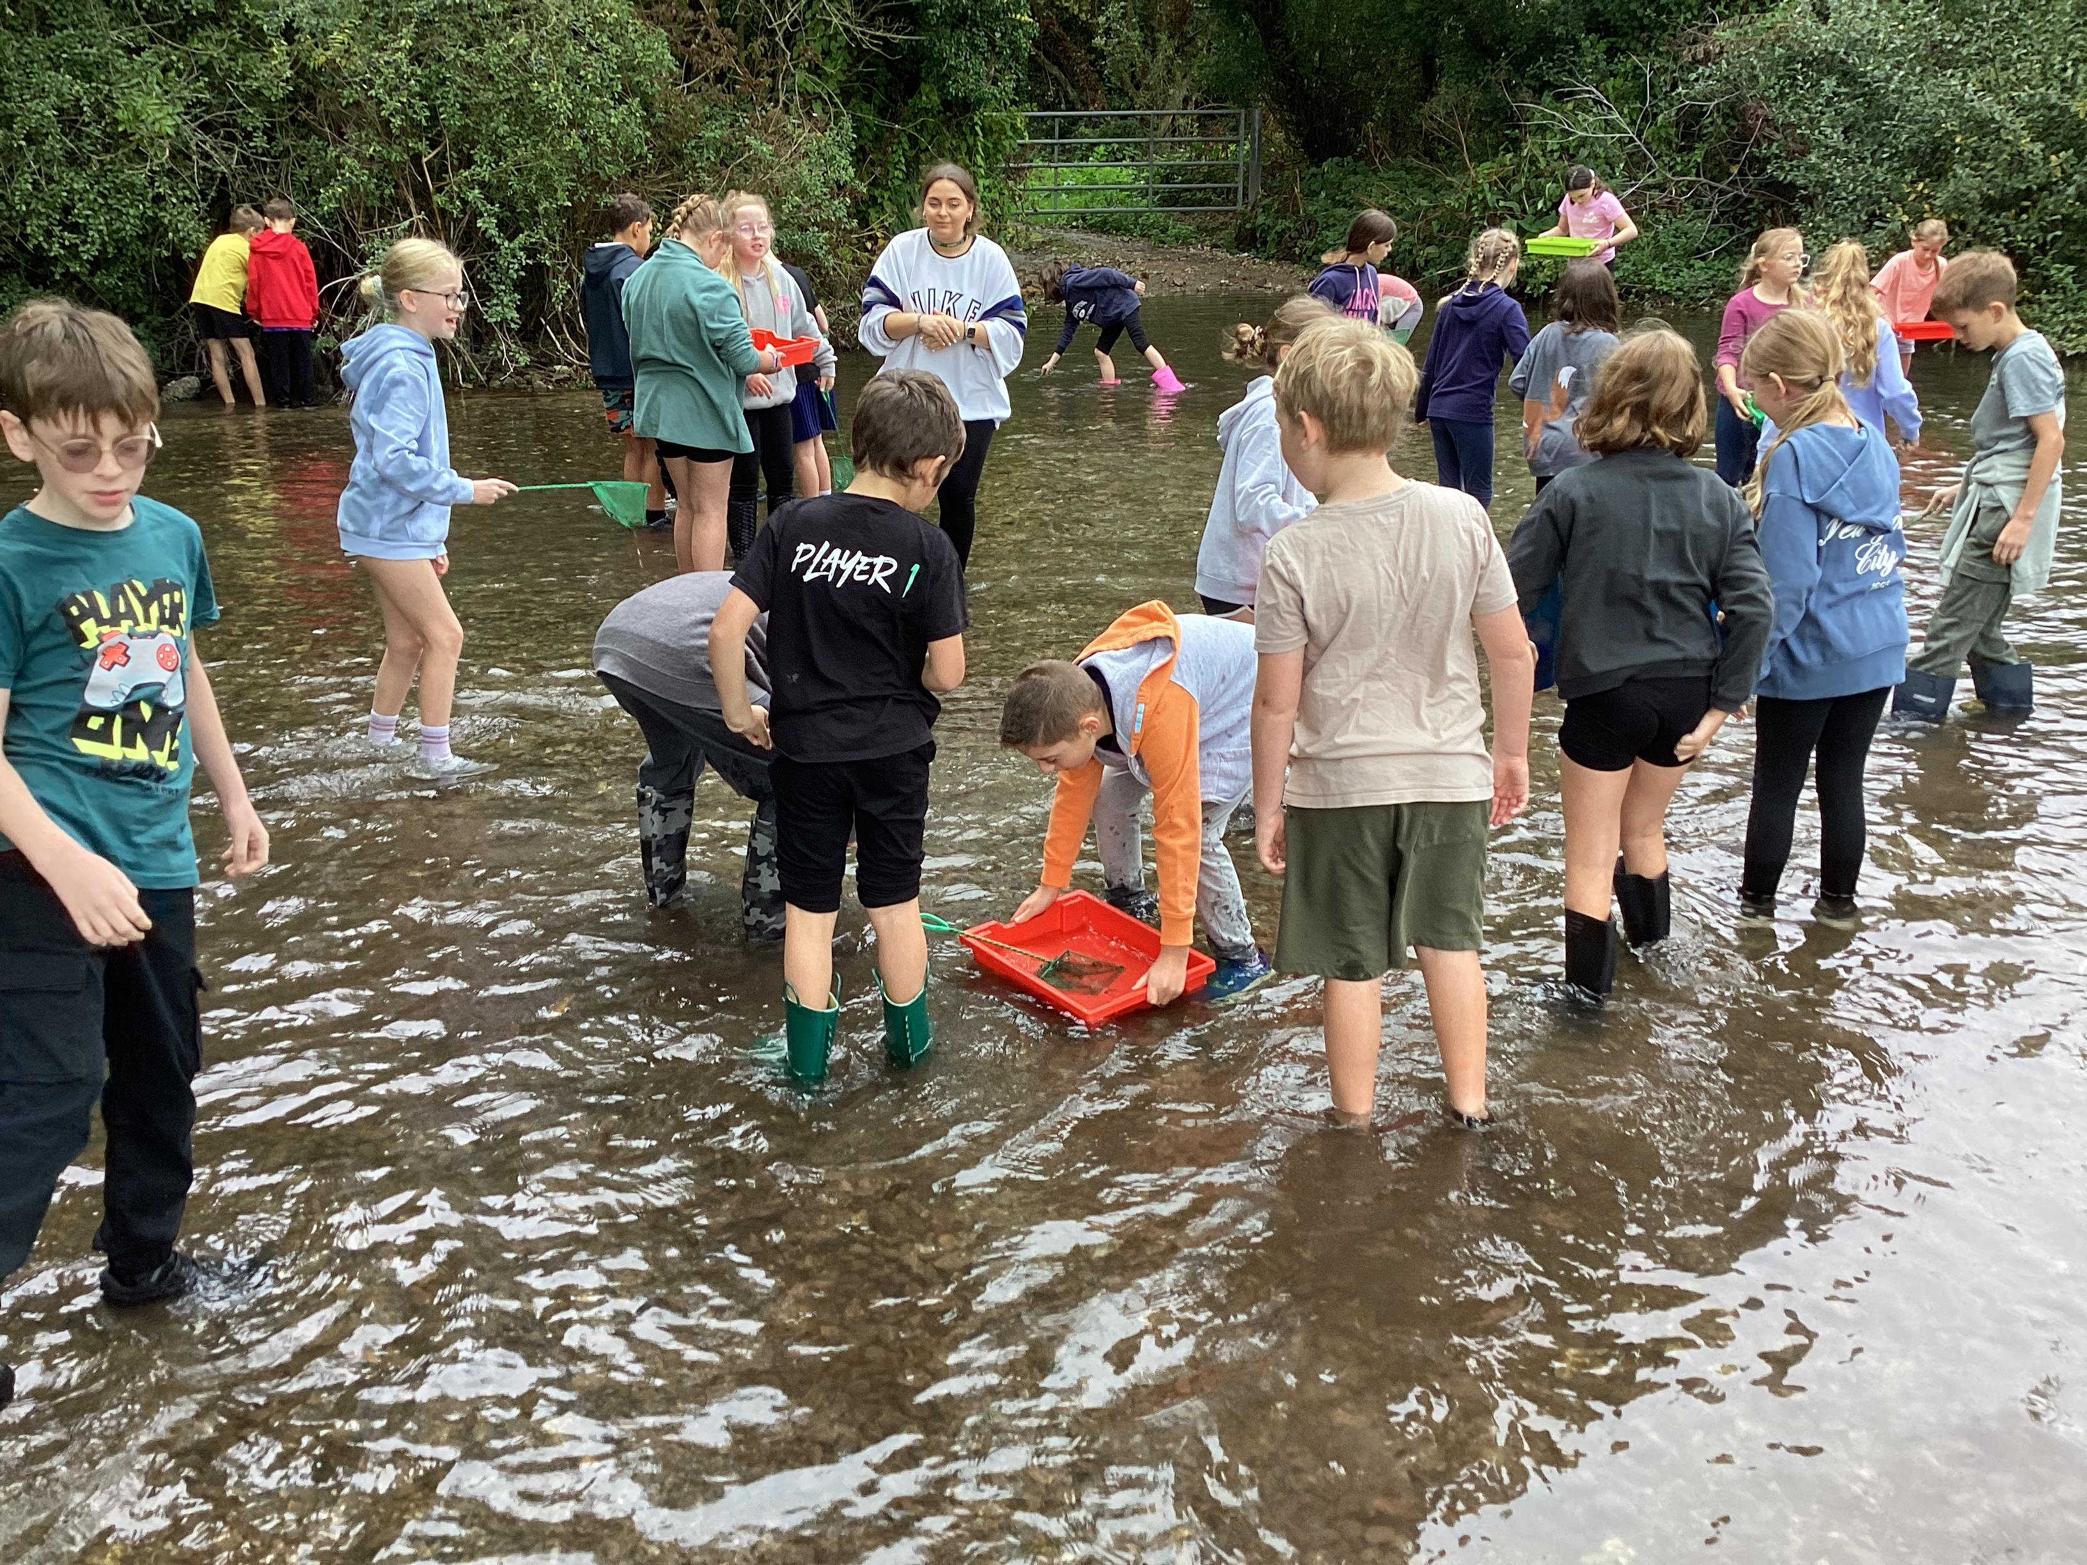

“I really like all the teachers in the school because they help us learn and they are kind. Sometimes we do lots of fun things. My best memory was when I started school and Mrs Woodfine played with us.” Ella
CURRICULUM
Staff and governors work closely together to ensure all children are given the opportunity to reach their highest potential. A School Development Plan is drawn up each year with a wide range of action plans aimed at further advancing the quality of education and experiences we offer and raising the standards of achievement throughout the school.
We aim to provide a caring but stimulating environment where each and every child is treated as an individual with their own special needs and talents.
Our school seeks to provide a broad and balanced curriculum which enriches the educational experience of the child. We aim to inspire, empower and involve all children in an accessible, relevant and exciting approach to learning. We enrich the curriculum through cross-curricular work, residential trips, outdoor visits, visitors and special themed ‘dress-up’ curriculum days.
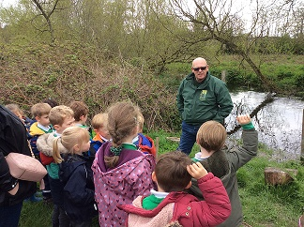
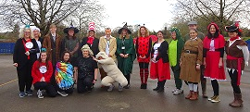
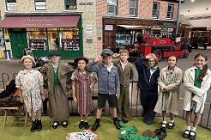
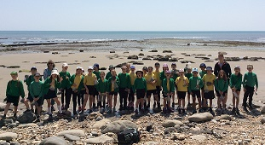

SPECIAL EDUCATIONAL NEEDS & ABLE GIFTED AND TALENTED
Winterbourne Earls welcomes all children into our school community and all are given equal opportunities to experience the full curriculum and to develop their talents wherever they have a particular strength. Where necessary, the school can draw on the help of our Special Educational Needs Coordinator, the expertise of the Local Authority Special Needs Support Team and other key agencies to ensure all pupils are able to continue their physical, social and mental development. The school aims to work in partnership with parents recognising that they play a key role in the education of their children. We aim to ensure that children with particular abilities are helped to realise their full potential. Learning is designed at an appropriate level for all pupils ensuring challenge for those who are identified as gifted and talented.
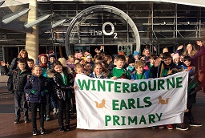
“I feel happy at school and I love playing with my friends. If I’m not feeling happy I go to the teachers and they help me or I go out with Mrs Morgan-Tranter (ELSA support).” Lexi
“I used to be extremely slow in my writing and now I have speeded up substantially all because the teachers helped me.” Luca

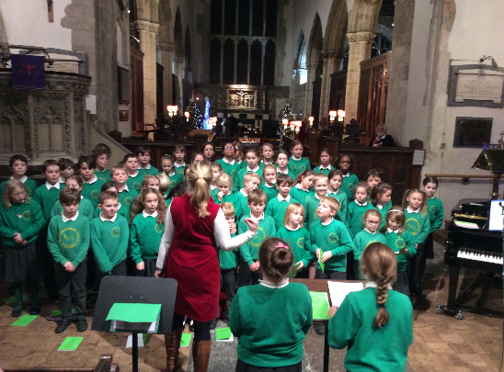
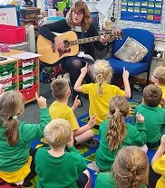
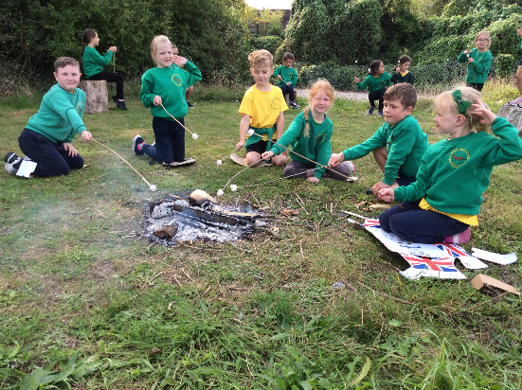
OFSTED INSPECTION – MARCH 2024
Following a rigorous Ofsted Inspection in March 2024, we continue to be a good school.
In the report, which can be viewed in full on the school website, the inspector stated that:
“Pupils flourish in this nurturing school. The school’s vision ‘as each one does their part, we grow in love’ underpins the family ethos. Pupils live out the school’s Christian values. They are polite and welcoming. Older pupils act as buddies to help younger pupils settle into school life. Pupils of all ages play happily together at breaktimes. The school provides strong pastoral care. Pupils know that they can talk to adults about any worries. Pupils feel safe in school and attend regularly.
The school has high expectations for pupils’ learning and behaviour. Pupils want to do their best.”
THE SCHOOL DAY
Class doors are open from 08.50 and we expect all children to be inside by 09.00. Registers will close at 09.00. Arrivals after the registers have closed will need to be signed in by a parent at the school office. These late arrivals are marked as unauthorised absences. Children should be collected at the end of the day at 15.20. Please let the class teacher know if someone else is collecting your child.
- 08.50-09.00 Arrival and registration window
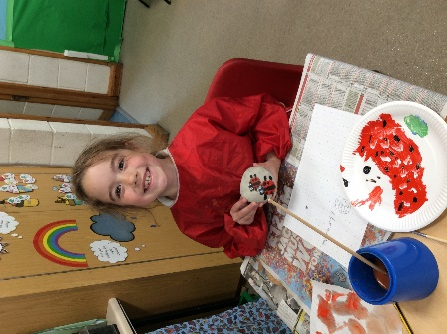
- 09.00 School starts
- 10.30-10.45 Break for all children
- 12.00-13.00 KS1 Lunchtime
- 12.10-13.00 KS2 Lunchtime
- Daily Worship
- 14.30-14.45 KS1 Break
- 15.20 End of School

SCHOOL UNIFORM
There is a school uniform which all children are expected to wear and should be clearly labelled. The school colours are green, grey and yellow. School branded green sweatshirts, cardigans and yellow PE T-shirts can be purchased on-line from www.gooddies.co.uk . Jewellery is not allowed. Children with pierced ears should have a single, small, plain stud earring only. All long hair needs to be tied back away from the face. Hair extensions, dyed hair and extreme haircuts, such as tram lines, are not permitted.
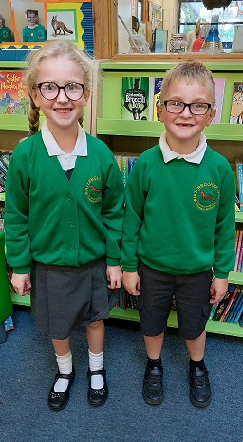
Winter Uniform
- Grey/black trousers, pinafore or skirt
- White polo shirt
- Grey, white or dark green tights or socks
- Black school shoes (boots or trainers are not allowed)
- Green school branded sweatshirt or cardigan
Summer Uniform
- Grey/black trousers, shorts or skirt
- White polo shirt
- Green/white striped or gingham dress
- Grey, white or dark green socks
- Black school shoes (open-toed sandals or trainers are not allowed)
PE Kit
- Yellow T-shirt
- Black shorts or black jogging bottoms/leggings in winter
- Trainers or plimsolls

School branded green book bags and draw-string PE bags can also be purchased on-line through the school shop and from the school office.

SCHOOL FACILITIES
The school was founded in 1872 and moved to new buildings in 1992. A permanent extension was added to the school in 2001 and another in 2010. The school currently comprises of a hall, 7 classrooms (each fitted with an interactive touchscreen whiteboard), a large Design and Technology room, two mobile classrooms which house KS2 classes and the Tree House, built as a hub for our pastoral support, which is used for group/ individual learning and meetings. We have recently created a Nurture Room where children can seek quiet and comfort away from the bustle of the classroom and is also somewhere that staff can interact with children who need some dedicated 1:1 time. Facilities in the hall have also been updated to include an interactive whiteboard screen with speakers, making presentations for whole school worship more engaging. We have extensive grounds with a playground, a playing field enjoying incredible views of the Bourne Valley, an adventure play area, a trim trail, a school vegetable garden, a fabulous outside fire pit and story-telling circle and a quiet reflective area/prayer garden. Our Parent Association FoWES, were generous in updating the playground last year with interactive markings and games for the children to enjoy during break times and also to serve as tools for outdoor learning. We have an on-site kitchen where an external catering company provides both hot meals and packed lunches.
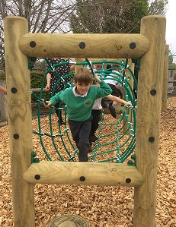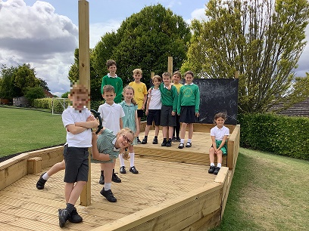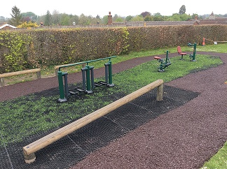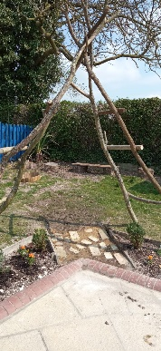

“We are lucky that we have a large school field that backs onto open countryside with spectacular views of the hills beyond.” Ollie C
“We hired builders to build special climbing frames on our banks and it means we can have the best break time ever.” Charlie

COMPETITIVE SPORTS AND SWIMMING
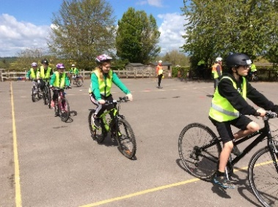
Sport is an area in which we excel as a school, with lots of success in local tournaments, particularly running in the Mini Marathon, swimming and football. We send teams to compete in football, netball, rugby, hockey, cricket, gymnastics, orienteering, swimming and athletic competitions. We also offer children opportunities to participate in festivals where the focus is more on enjoyment and skill development than competition. Every class takes part in a minimum of two PE sessions a week. Thanks to the generosity of Chafyn Grove School, we have been lucky enough to offer swimming lessons at their open-air pool for Year 3 and 4 pupils.
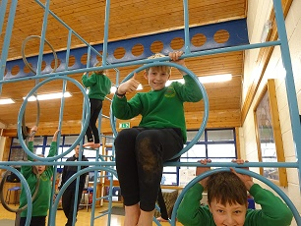
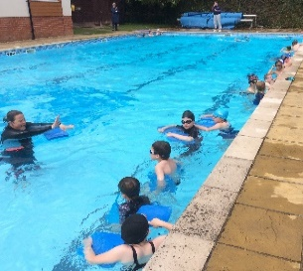
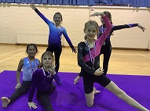

EXTRA-CURRICULAR ACTIVITIES
We offer extra-curricular clubs organised by external professional coaches, class teachers and parents covering many different sports and activities. Clubs vary during the year, with parents informed about them as they become available. We have a very active choir with most children from KS2 attending!
“We have lots of new sports equipment and a variety of after school sports clubs. We are given the opportunity to compete against other local schools and we usually do well. I loved the gymnastics festival with lots of specialist equipment that we could use.” Isla

THE FIGSBURY CHALLENGE
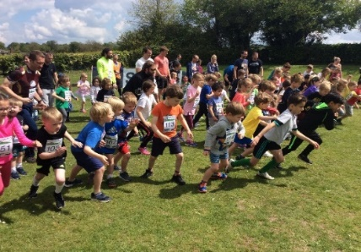
The Figsbury Challenge, which is a highlight of our school calendar, is a challenging 5km run up to and round Figsbury Rings, a National Trust site behind the village, with 1km and 3km fun runs for younger participants. This highly successful and enjoyable day is organised by our Parent Association (FoWES) as a fundraising activity, but there is a strong focus on encouraging every member of the school community, child and parents, to take part in some way on the day.
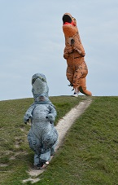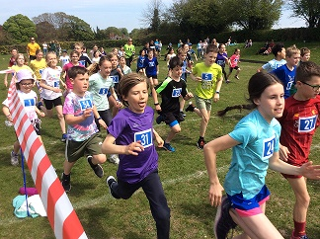

PARENT-SCHOOL COMMUNICATION
We value our strong relationships with parents, whom we recognise as important partners in learning. Parents are warmly encouraged to help on trips or themed days or to volunteer to help in class with reading/tables practice; this support is much appreciated. We organise class workshops to keep parents abreast of new teaching methods or specific ways in which to support learning at home. Lately the focus for these workshops has been reading comprehension, maths mastery and modelling story writing.
Parents will receive information via:
- Arbor – all communication via email, trips information, after school clubs information, lunches and all payments are via this system
- See-Saw – learning platform for communication between parents and class teacher
- Annual mid-year reports on children’s progress
- Teacher-Parent Consultation Meetings
- Parent workshops
- School website: www.winterbourneearls.org

“The work ethic and the excellence displayed by your teaching staff are truly admirable and are built upon the strong foundations you have established. Additionally, the support staff play a crucial role in securing and fostering the well-being and intervention for the students” Mr P (Parent) 2024

FRIENDS OF WINTERBOURNE EARLS SCHOOL (FoWES)
We have a very active fundraising Committee—Friends of Winterbourne Earls School (FoWES) - that makes an invaluable contribution to the life of the school. It does this not only in terms of its fundraising, but in promoting the role of the school as part of the wider community, and in reinforcing the strong relationships between school and parents. The committee, which includes representatives of both parents and staff, but also local residents, works closely together to raise funds.

The money raised by FoWES enables us to enrich the curriculum for all our children. Educational visits and residentials can really bring alive work done in the classrooms, and are made affordable to parents by the financial contributions made by FOWES. The children have also been able to experience live theatre groups, musicians, and science activities in school. In addition, we have been able to do things such as completely restock our library and buy additional PE, Science, Early Years resources and computing equipment. This year FoWES helped with a new sound system, sports kit and repairs to the playpark. Events are always imaginative, enjoyable and well supported by the whole community. Fox Fest is a particular highlight!

FoWES run a Tuck Shop every Friday as well as a ‘Pre-Loved Uniform’ shop where parents can purchase good quality donated items of uniform.

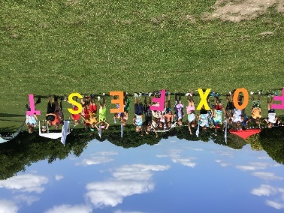
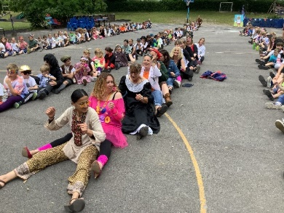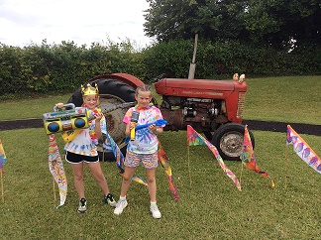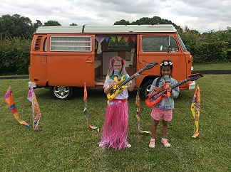

“I love the special days we have and the school trips. Fox Fest was so amazing- the entertainment like the stilt walker was extreme! I love the Christmas Fete because we have competitions and stalls and the staff dress up as elves. We love prizes from the DJ at the disco for best dancing and singing.” Daisy
“Most children display exemplary attitudes to learning and show resilience when tackling learning. Pupils say that they enjoy opportunities to work collaboratively and value the attention their teachers provide to support them when they are finding new learning hard.”

OFSTED Report, 2018
“Led by the Headteacher, dedicated and passionate staff and committed governors ensure that pastoral care, mental health and wellbeing are priorities for all in this family Christian community. The academic and spiritual needs of each individual are met very well, especially vulnerable pupils, including those from military communities.”
“Inspired by collective worship, pupils are conduits of change and are helping to make a difference in society, locally, nationally and globally.”
SIAMS Report 2019



We are now part of Pickwick Academy Trust

Welcome to Pickwick Academy Trust. We are a primary-only Schools Trust with 21 church and non-church schools organised into three geographically proximate hubs in Wiltshire and North Dorset. Pickwick was established in 2017 by four schools seeking to build on and formalise the benefits they saw through collaborative working as part of our Teaching School Alliance. It is this foundation that underpins our developmental school improvement work and commitment to strong professional development. We
believe in mutually beneficial partnerships with our schools and ensure they retain and celebrate their unique identities, ethos and values - we do not want a set of clone schools!

For further information please visit:

https://www.pickwickacademytrust.co.uk/

