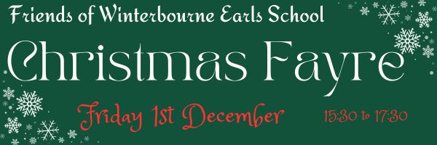
It’s the most wonderful time of year again!! FoWES will be hosting the annual Christmas Fayre on Friday 1st December (15:30 til 17:30).

Lead Elf Carter will be opening the Fayre with the school choir singing some wonderful festive songs.
The big man himself will be visiting us again, letters have gone home. Please ensure forms are returned by 24th November to secure your place.

There will be a Grand Christmas Draw to raise money for Playground markings. Up for grabs is £100, a Kindle Fire, a Hamper plus many more fantastic prizes.

A “Hollywood” style handshake may be delivered if any of the bakes for the Christmas Bake Off deserve it!! Please submit your entries to school by 09:30 on the morning of the 1st December (with a list of ingredients used). All entries will then be sold at the Fayre. Ready….get set.. BAKE!

We will have a games room run by year 5, a craft room and facepainting / festive tattoo area, Guess the Name of the Cake and Tombola’s.

On Friday 24th November your child can come dressed to school in something sparkly or festive (or an alternative option). Please either bring in an alcoholic bottle or £1 for our adult only boozy tombola! There will also be a Chocolate Tombola and a Teddy one!

Entrance will be £1 per child. Each craft will cost £1, it will be a £1 to enter the Games Room, Facepainting 50p and Tattoo 50p. Please bring cash or you can purchase punch cards for £5 or £10 from tuck shop prior to the night.

Along with the tasty bakes you submit we will be selling festive food and drink at The Candy Cane Cafe.

In order for all of this to go ahead we really do need your help. We have a google volunteer form: Volunteer Form
Slots are no more than half an hour as we want everyone to enjoy themselves. Some activities may not go ahead on the day if we are short of people to help.

Yours Festively
The Friends of Winterbourne Earls School Team

