Reception Expectations for the Prime Areas of the EYFS Curriculum

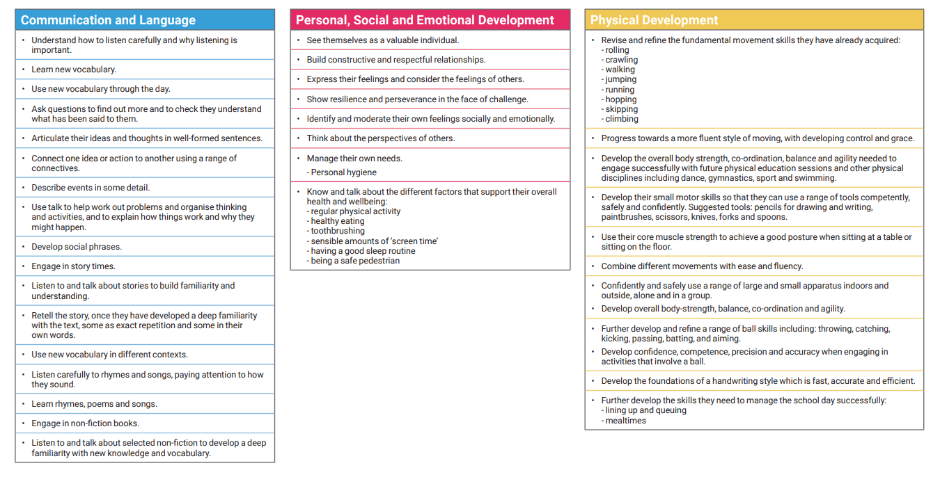

Reception Expectations for the Specific Areas of the EYFS Curriculum



